ECE297

Final Report

**Team cd042 CI: Michelle MacArthur**

Timothy Chan

Zihang Fu

Li Ting Wong

Executive Summary

Due to the high usability and increasing popularity, a GIS was designed to improve upon the other systems in the market. According to research, there are around 13.7 million people visiting Toronto every year[1], and our team sees the potential of creating a GIS tailored for the special needs of travelers.

Various design decisions were made based on the core values of the team, to provide a positive user experience, in order to perfect our GIS. Firstly, special features designed for travelers were implemented. Filters were created for users to filter out point of interests (POI), which assists them to find the locations that provide services they need. Besides, a save function was developed for users to keep track of the locations they plan to go.

Secondly, a user friendly navigation system was designed for the ease of use. An intuitive navigation system that provides location search and recommendations was implemented, aiming to provide a simple and great user experience.

Thirdly, a simple user interface with contrasting colours and highlighted important features was created to meet the team value of providing a clear visualization, which optimizes the user experience. On top of the colour scheme, street and POI names are displayed based on the zooming level and the location of the cursor respectively. These user interface features are also dedicated to the team’s value of a clear map visualization.

Travel map is still in its early development stage. Currently, the map system is customized to the geographical features of downtown Toronto. In the future, travel map will be improved by extending the map’s features to different cities and enlarging the current database with more information that are useful to travelers, such as public transits and opening hours of stores.

Finally, other useful features will be developed in the future, including a small map with a bigger scale to track the displaying window’s location, finding optimized path between points selected using the cursor, and saving multiple paths.

1.Introduction

2.Technical Overview

2.1 High-level code overview

2.1.1 Work flow

2.1.2 Implementation

2.1.3 Important Files

Database and Database Library

m1

Graphics

m2

m4

2.2 Algorithm

2.2.1 Graphics and Interface

Streets

Street Names

2.2.2 Path Finding & Courier Company

Pathfinding Between Two Points

Pathfinding Between Multiple Points (Courier Company System)

2.3 Choice of data structure

2.3.1 Unordered_map

2.3.2 Priority_queue

2.4 Contribution of Each Member

Li Ting

Timothy

Zihang

3. Product Overview

3.1 Navigation

Usability

Interface

3.2 Point of Interests Filters

Usability

Interface

3.3 Save Locations

Usability

3.4 Performance

4. Lesson Learned

5. Future Development

6. Conclusion

7. List of References

8. Attributions

1. Introduction

Over the last three months, the task of designing and implementing a GIS that accommodates the specific needs of travelers was accomplished. The decision of producing a travel map was based on the insight of the team into the continually developing market of the traveling business[2]. Design decisions were made to create the travel map, which includes the filter function, save locations function and search paths function. These special functions are implemented to assist travelers in navigating the city. They have a clear visualization and a highly usable design that ultimately provide an outstanding user experience. In this document, details of the travel map will be discussed, starting with technical overview, where the data structures and algorithms are explored. In order to keep the code simple and easy to be understood, only necessary information was included in the structures. In the next section of the report, product overview of the map interface, features and speed of the system are analyzed. Core design decisions that led to the choice of map layout, special map features and timing analysis are also explained in this section.. Next, under the lessons learned section, improvements on both navigation system and data structures are discussed. Future development of the travel map is discussed in the last part of the report, concluding the designs and functions that are beneficial to be integrated with the travel map

2. Technical Overview

# 2.1 High-level code overview

## 2.1.1 Work flow

The GIS designed by the team is a travel map that converts a set of data into an interactive city map. Additional features such as navigation and point of interest filters were developed. Overall, the program works as follows:

1. User starts the program and selects a city
2. Program extracts data from database and draws the map
3. User inputs to the program
4. Program reacts to user’s inputs and displays the result on the map

## 2.1.2 Implementation

Although a raw database is given initially, due to the consideration of performance, raw data are written into other data structures when the program is started. Using those data structures, the program draws the map of the city on easyGL. Next, the filter buttons and a dialogue box will appear in the graphic window and ready to take user input. Once the program receives a proper input, it extracts and computes the required data from data structures and displays the result on the graphical window.

## 2.1.3 Important Files

The GIS is constructed with many files. Important files and their contributions to the project are discussed in this section.

### Database and Database Library

A database is a collection of information including streets, intersections, point of interests and natural features of a city, and a database library contains functions that are used to access and extract data from the database.

### m1

m1 is the basis of the program that contains the data of the map and controls the starting point of the program. When the program starts, functions implemented call the provided functions in the database library. Data are extracted from the database and re-written into the data structures created by the team. Also, m1 contains the functions that are used to access those data structures.

### Graphics

To display the map, easyGL, a graphical interface tool, was used. Graphics is a C++ source file that contains basic functions that drive the easyGL, such as draw_line and_draw text.

### m2

**m**2 contains all graphical parts of the program. Map data stored in data structures, such as streets and intersections, are extracted by functions in m1 and processed by functions in m2. Processed data are passed as input parameters to the basic functions in graphics.cpp to draw the map. Also, m2 includes a user interface that allows users to input to the program and use pathfinding functions in m3 and m4.

***m3***

m3 contains the implementation of the pathfinding function, which is one of the most important features of the program. A* algorithm is used to find the optimal route between intersections (or intersection to point of interest).

### m4

Based on functions in m3, pathfinding between multiple intersections is implemented in m4. 2-opt algorithm with multiple starting points is implemented to find the optimal route between multiple intersections. Also, multithreading is used when the program is performing 2-opt for different starting points to save CPU time.

# 

Figure 1: Workflow of the project and responsibilities of important files

# 2.2 Algorithm

## 2.2.1 Graphics and Interface

### Streets

At different zooming levels, the color and thickness of the local streets are determined based on their number of street segments; highways are determined according to the speed limits and are assigned with bright blue and bright red (for tolled highways) colors to distinguish from the local streets.

### Street Names

Frequency of displaying street names depends on the zooming levels. To avoid overlapping, the center of the text box is fixed at the middle point of a street segment, and the length is constrained by the length of the segment on the visible map.

## 2.2.2 Path Finding & Courier Company

### Pathfinding Between Two Points

To find the best route (i.e. least time consuming route) between two arbitrary locations, a modified Dijkstra’s algorithm (A* algorithm) is implemented. Based on the original Dijkstra’s algorithm which, from the start location, explores every possible street segment at every direction until the destination is reached, the A* algorithm abandons the street segments which go towards the opposite direction and increase the total geometric distance by more than 15 percent (Figure 2). This parameter is set from trials and errors so that the modified algorithm keeps the correctness and also improves its overall performance (Figure3).

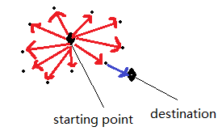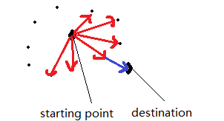

*Dijkstra’s algorithm: all street segments are A* algorithm: only street segments that*

*explored until the destination is reached possibly lead to the destination is visited.*

Figure 2: Difference between A* algorithm and Dijkstra’s algorithm

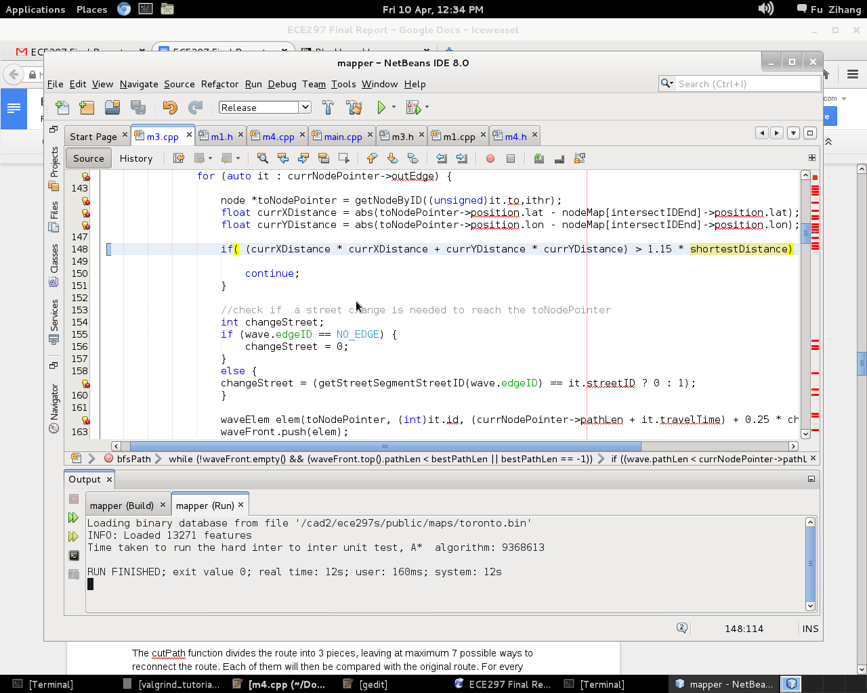

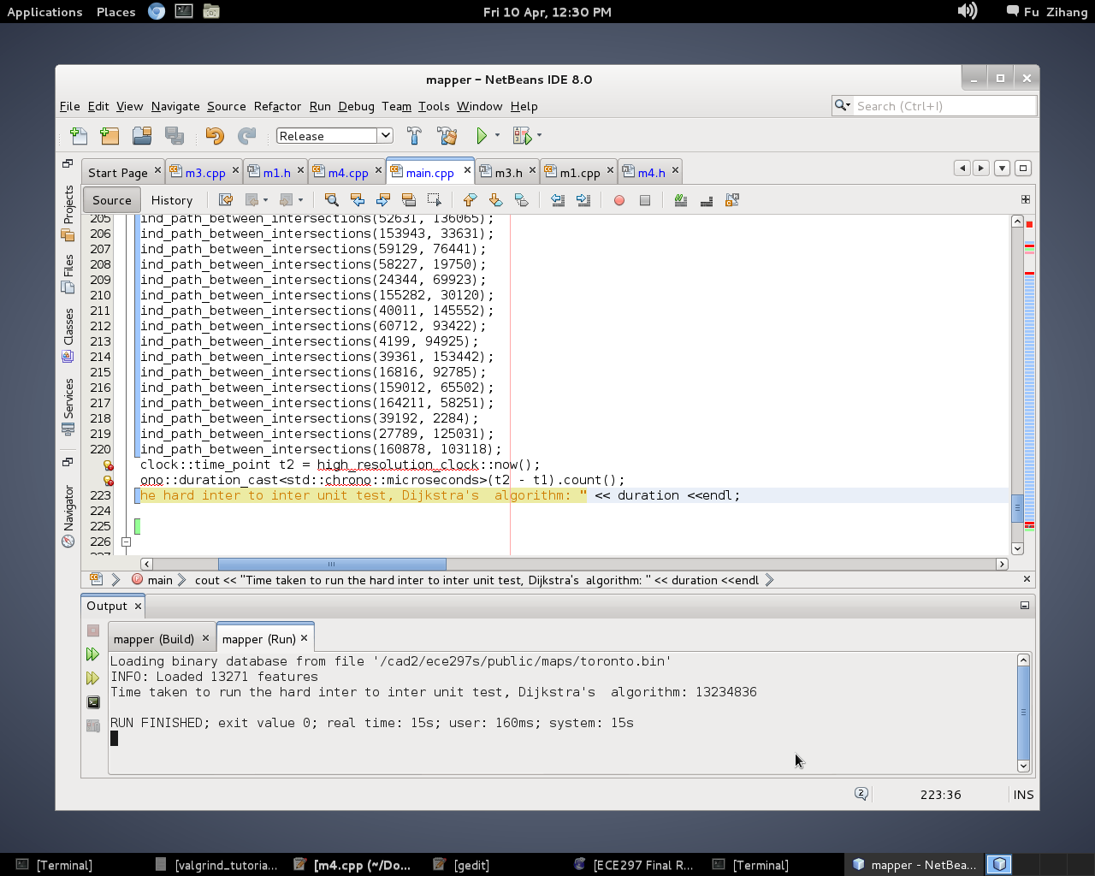

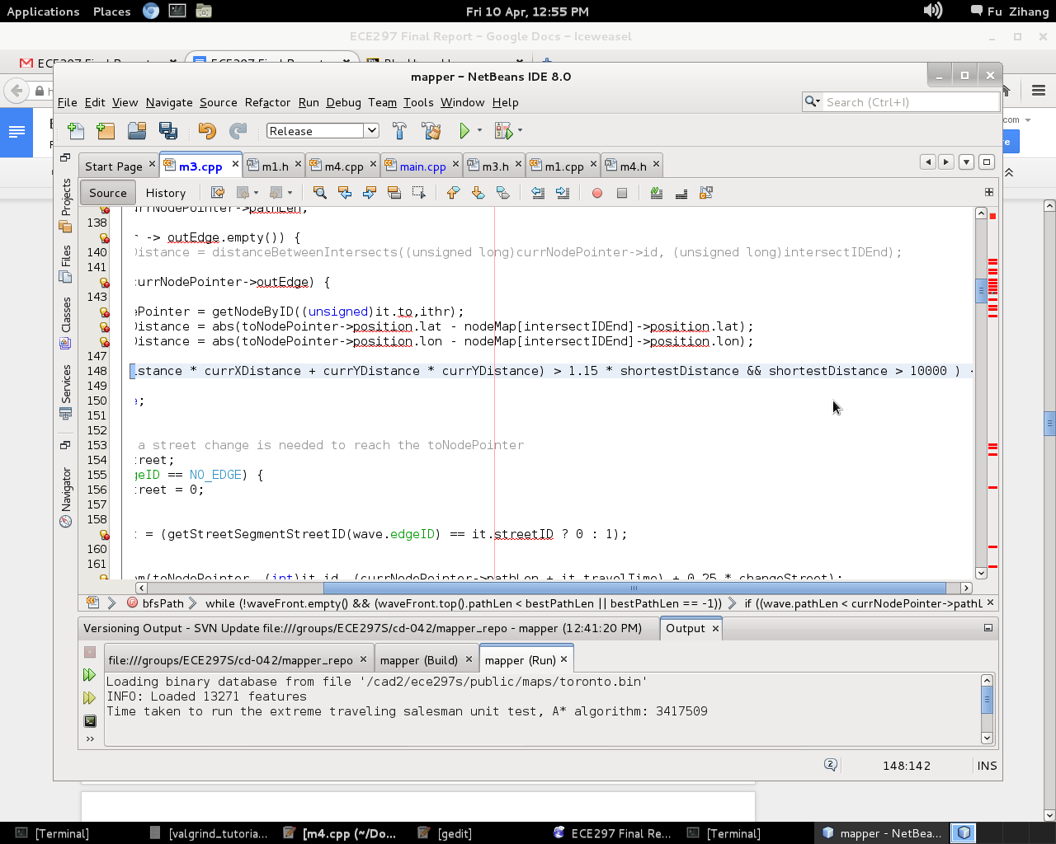

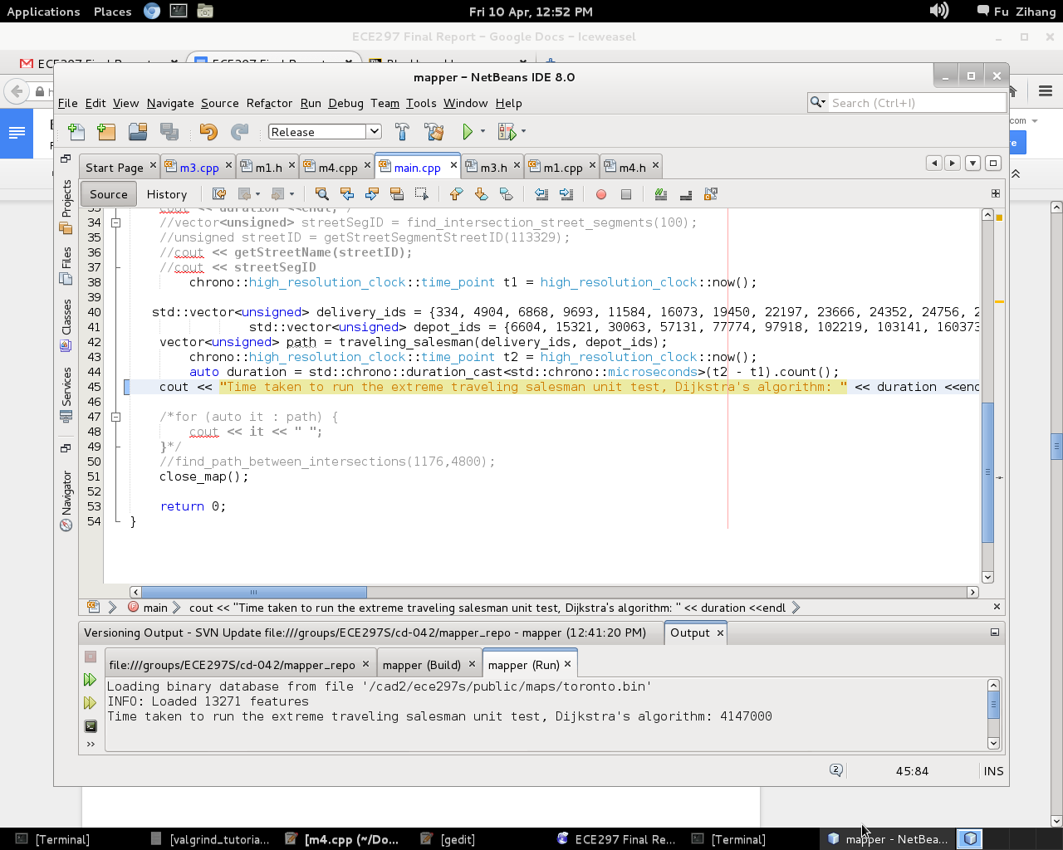

Figure 3 . Performance of A* algorithm v.s. Dijkstra’s algorithm. Time measured in microseconds

### 

### Pathfinding Between Multiple Points (Courier Company System)

In this part, the program is used to find the optimal route for a courier man who has multiple deliveries to make. The deliveries locations and depot locations are passed into the program for route finding. The route must begin with a depot location, going through all delivery locations and arrive at a depot locations at the end. To achieve this, the program first finds all “greedy” routes starting from each depot location. Then, each of these “greedy” routes is passed into a function called cutPath.

The cutPath function divides the route into 3 pieces, and reconnecting the pieces in 7 distinctive configurations. Each of them is compared with the original route. If a combination has a shorter travelling time, it is passed back to the cutPath function recursively; if not, the function cuts the route in a different way and repeats the comparison. The cutPath function returns the locally best route when there is no better path found.

The most optimized route among the few locally best routes produced is chosen as the final result.

# 2.3 Choice of data structure

## 2.3.1 Unordered_map

Unordered_map is used to store most data in the map, such as intersections, streets, and point of interests. It is chosen because it stores data as a key-value pair, which makes accessing data with unique identifications (e.g. intersections’ ID) easy. Also, as the STL unordered_map is implemented with auto re-hash function that ensures the size of data stored in each bucket is relatively small, it is suitable to store large amount of data (such as intersection information) with O(1) accessing complexity.

## 2.3.2 Priority_queue

Priority_queue is used in pathfinding functions,which frequently use the minimum member of all elements. The STL priority_queue always keeps the member with extreme value (maximum or minimum, depending on how comparison operator is defined) at the first position. This feature makes priority_queue perfectly suitable for pathfinding functions as the smallest member of a set can be easily extracted using member function “.top()” with O(1) complexity.

# 2.4 Contribution of Each Member

## Li Ting

* Basic m1 functions
* Drawing of streets
* Design and implementation of user interface
* Greedy path and simulated annealing (not included in final submit)

## Timothy

* Basic m1 functions
* Drawing of attributes and point of interests
* Filter function and push buttons
* 2 - opt algorithm to find optimal path between multiple points

## Zihang

* Basic m1 functions
* Displaying of street names
* Pathfinding algorithm for 2 points
* Pre-computation part for m4 and simulated annealing (not included in final submit)

3. Product Overview

The core design of the vel map travel map is to provide the functionalities that are useful to the travelers, as such, various design decisions were made to meet the needs of travelers. In particular, special features including navigation, filters and save locations are implemented. Moreover, the ease of use of the graphical interface directly relates to the usability of the GIS. For the reason, one of the value propositions of the product is an intuitive design that has a clear and simple UI. Therefore, each of the special features mentioned above are accompanied with a user interface that is carefully designed to deliver the best user experience.

# 3.1 Navigation

### Usability

The navigation system was developed to assist travelers in planning and exploring a foreign city. Firstly, travelers are usually unfamiliar with the city and therefore have hard times in locating themselves. The system provides a search location function allowing them to search for a position. Users can locate themselves and the places they planned to go on the map, and discover restaurants and attractions in their surroundings. Secondly, the system optimizes the route between the initial location and the destination. The function helps users to find a correct and time-saving route in an instant, which is especially useful for the ones who are tight in time. Thirdly, the search function for multiple destinations provides a convenient option for users to plan a trip with more than one stops.

### Interface

A graphical user input method was implemented with the navigation system. Users can type anytime to search when the map is running, and the search results will appear in the textbox located at the upper left corner. If the user inputs too many characters such that the text is out of the bound, the textbox maintains a clear visualization by shifting the text to the left and displaying the newly typed characters. This allows the user to clearly see what they are typing(Figure 4). The textbox also supports backspace deletion for editing the text, and a hot key “ctrl + d” to clear all the text at once. For every “space” input, a new search is triggered, and the recommendations based on the new input is displayed in the navigation panel with the best match listed at the top. The user can use up and down arrows to scroll through the recommendations(Figure 5). The selected recommendation is highlighted for clarity, and the user can press “enter” to select and locate the recommended location on the map(figure 6).

In order to add destinations, users can use left and right arrows to switch through the “To/From/POI” boxes(Figure 5). The best route will be calculated and illustrated on the map whenever the user search under TO or POI boxes. To add or remove destinations, users only need to press “ctrl + enter” on the selected recommendation to add in the destination list, and press “ctrl + backspace” to delete an unwanted destination.

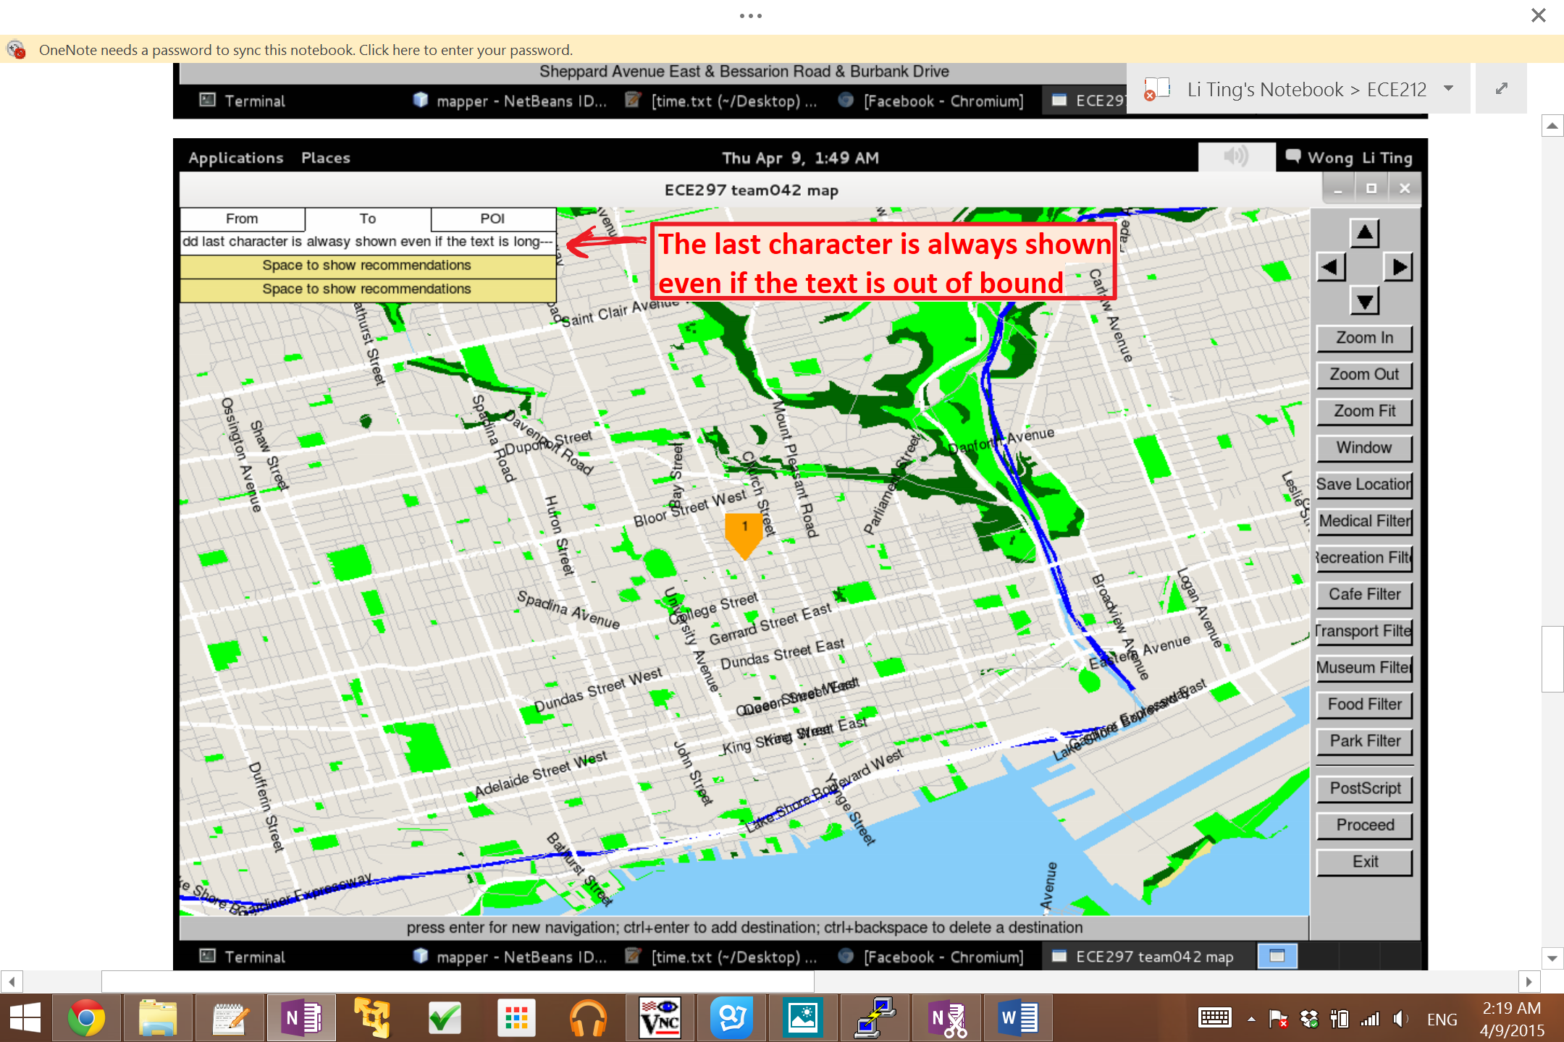

Figure 4: Demonstration of the display of the text

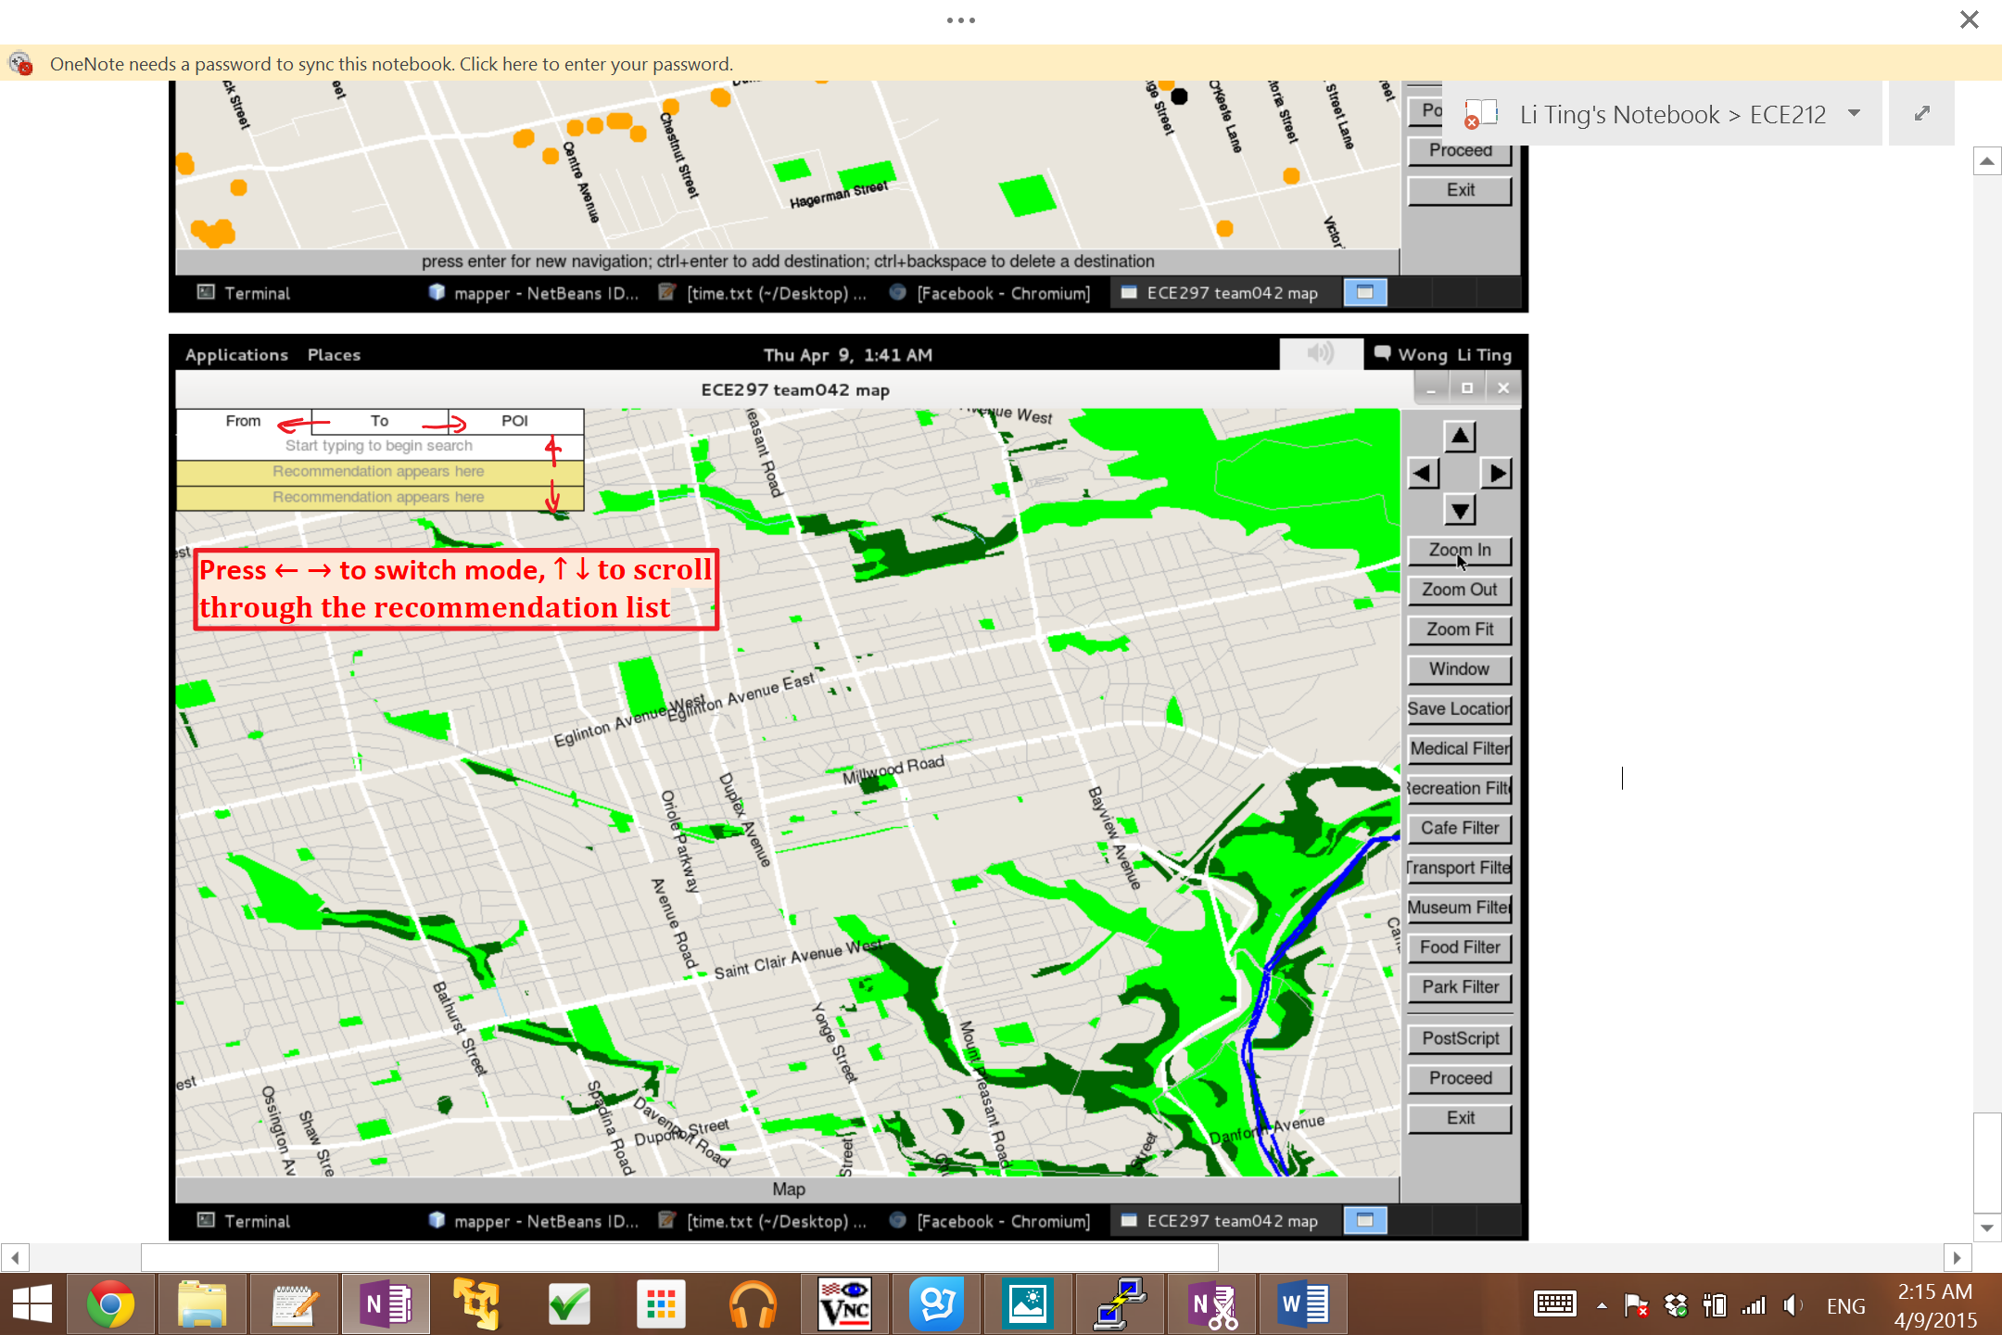

Figure 5: Demonstration of the navigation panel

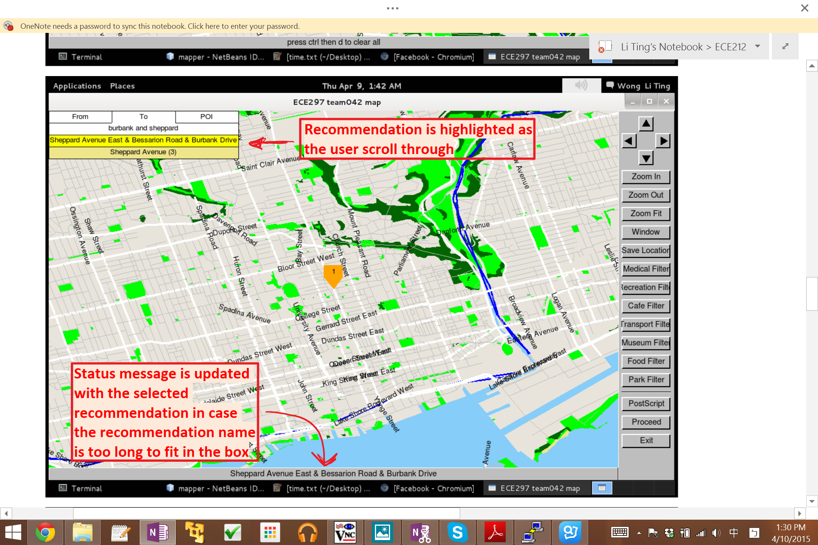

Figure 6: Demonstration of the search result

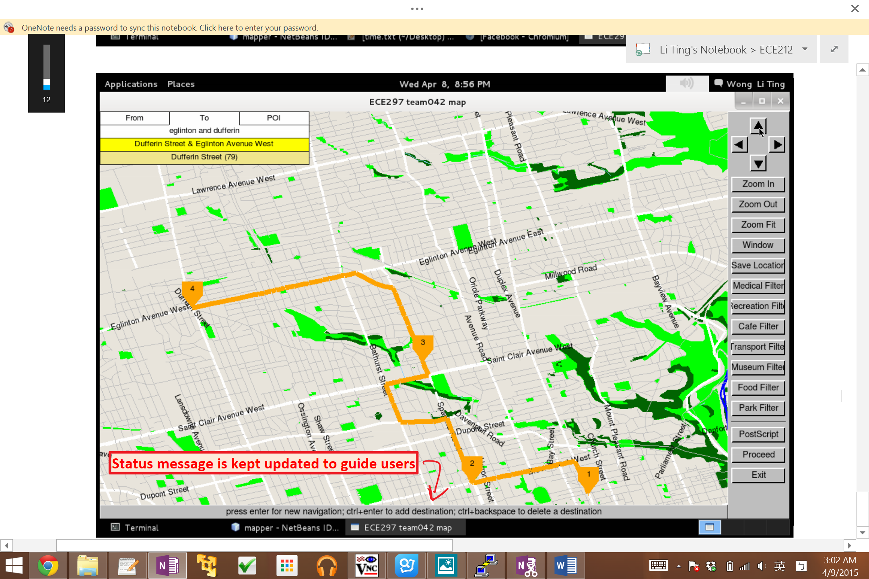

Figure 7: Demonstration of the multi-destination pathfinding

# 3.2 Point of Interests Filters

### Usability

Besides the predetermined places that the travelers planned to go, it is also important to present the travelers an option to explore the surroundings by displaying all the relevant POI at once, and the POI filter is designed for such use. Seven buttons were created including the “Medical”, “Recreational”, “Cafe”, “Transport”, “Museum”, “Food” and “Park” filters, to provide a wide range of options for the user to fully explore the surrounding area. For example, when the users want to see all the food providers around the area, the “Food” filter could be used to display all the nearby cafe’s and restaurants.

### Interface

A button for each filter category is created. When a user clicks on a button, dots are drawn on top of the map to represent the stores. For clarity, the names of the stores are not shown to avoid text overlapping; alternatively, user can hover the mouse over a dot to check the name of the store(Figure 8). Multiple filters can be easily applied by clicking on multiple buttons, and since each button has an associated color with it, user can easily distinguish different POI by examining the colors.

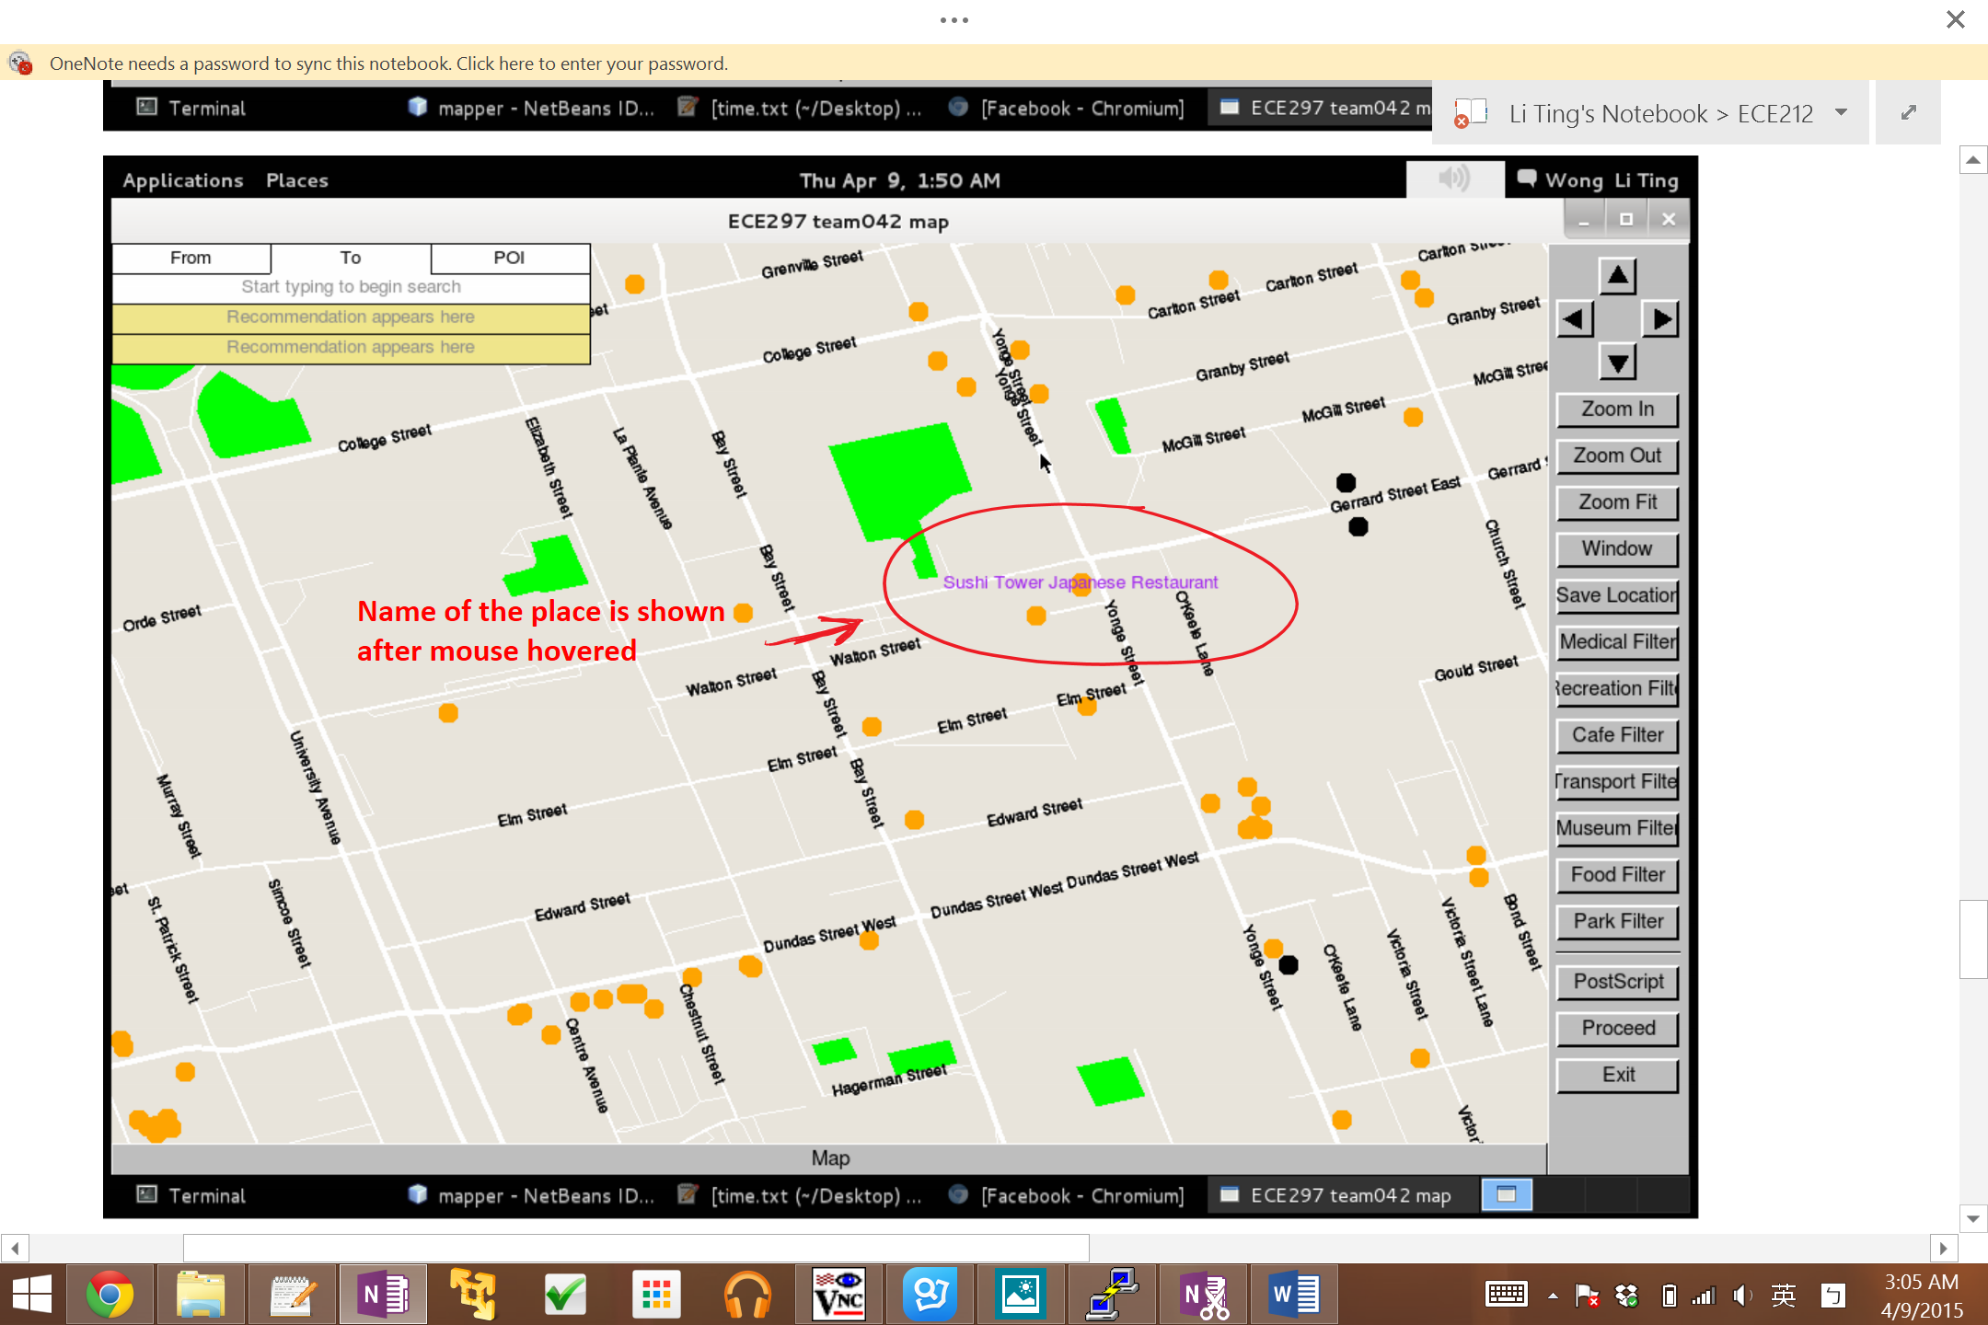

Figure 8: Demonstration of the filter

# 3.3 Save Locations

### Usability

Save location function is implemented to help travelers planning their trip. It is a function that let users to put a mark at any place on the map. With the function, users can easily see all the interested locations geometrically at once.

**Interface**

A button labelled “Save Location” is created. Users can click on the button to enable the function, and start putting marks on the map. The marks have the shape of “+’ and are colored with bright red for clear visualization. The function can be disabled by clicking the button again.

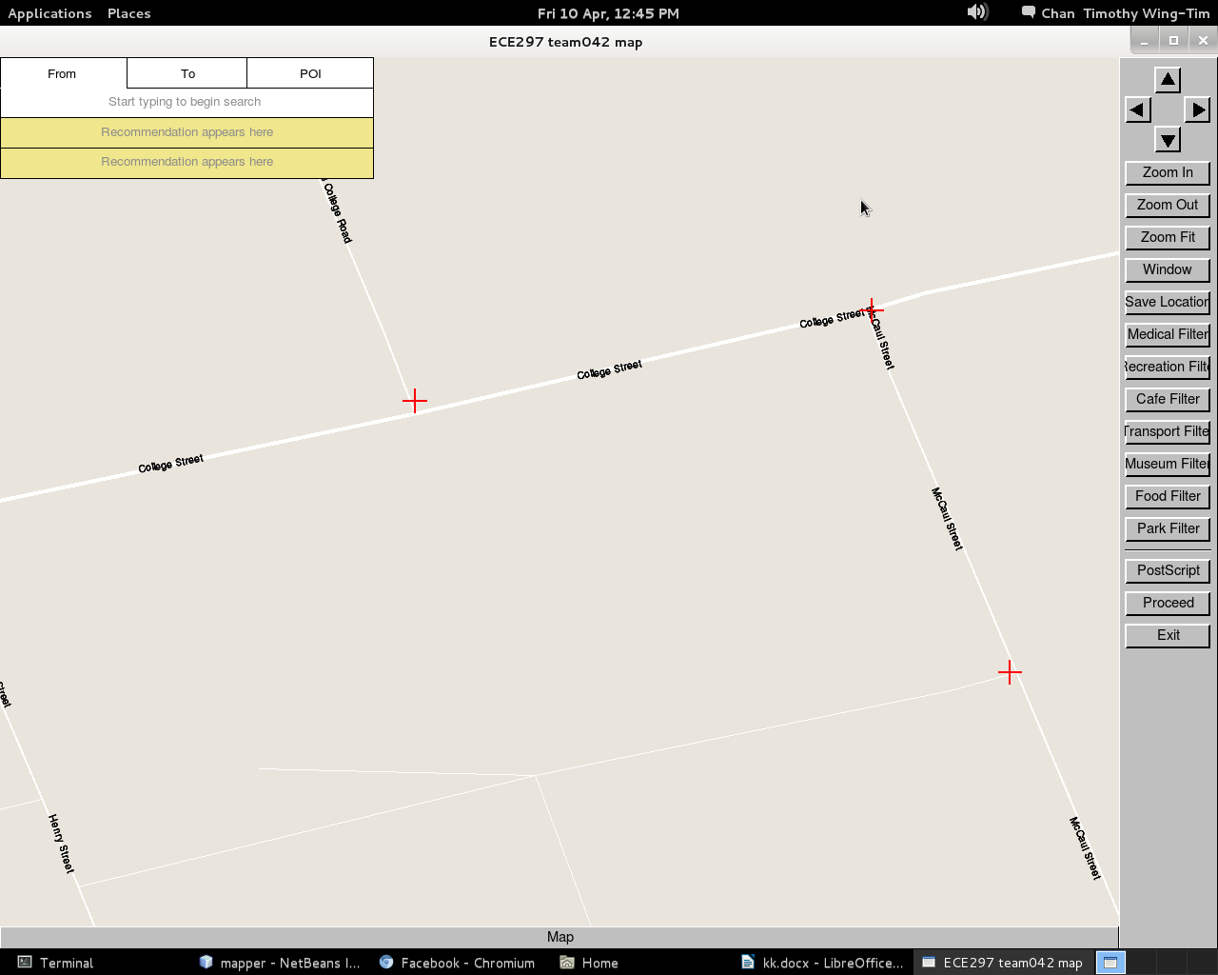

Figure 9: Demonstration of the save location function

# 3.4 Performance

Travel map not only has various functionalities to assist travelers, it also has a high speed performance to ensure the usability of the map. Drawing map takes a mere 0.25 seconds; searching for places takes less than 0.01 seconds; finding and drawing one-to-one path on the map takes around 0.025 seconds, and even for multiple destinations, the map can carry out the task under 2 seconds for up to 10 destinations(using greedy path method). The responsive time are on par with Google Map(by inspection) by comparing the time of finding and displaying a new route. The map is able to deliver a positive user experience with the various functionalities, great UI and fast performance.

4. Lesson Learned

The project was well planned and all the features specified in the design proposal was implemented. However, there were design decisions that could be made differently and potentially improve our final product.

Firstly, a function that allows users to navigate by dropping pins on the map can be implemented to consummate the current navigation system. At the current stage, a search function integrated with a draw path function was implemented (Figure 10), allowing users to find the most time-saving path between intersections or POIs by simply putting the names of the locations in the search box (Figure 10). The method is simple to use if the user knows the exact names of the locations. Yet, visitors from a foreign country might not have the knowledge about the city. The pin dropping method allows users to locate two points easily and eliminate the needs of knowing the names of locations prior to searching the best path.

Secondly, the speed of the of the map was lowered after implementing the draw path function. In the current design, the find path function is called whenever the map is refreshed, which takes about a second to find the best path. It is much slower than the original speed of the map (less than 1/10 of a second). In the future, the current path can be saved to avoid recalculating every time the screen is refreshed, and the path is only updated when a new search is performed. This simplifies the task undertaken by draw path function, and thus speeds up the map significantly.

Thirdly, the data structure could be structured better before the implementation of the milestones. In order to simplify the code, only essential data at the time of milestone 1 was included in our primary data structure. The initial data structure includes an intersection unordered map and a POI unordered map. The structure was enough at the time in milestone 1 but became insufficient as the project got more complicated. Extra data structures were created to compensate the lack of information, including streetData map, feature map, node map and allPoi map (Figure. 11). The unorganized data structure would cause confusion to people who were unfamiliar with the code. In order to resolve the situation, a more extensive data structure which groups similar structures could be implemented for a clearer design..

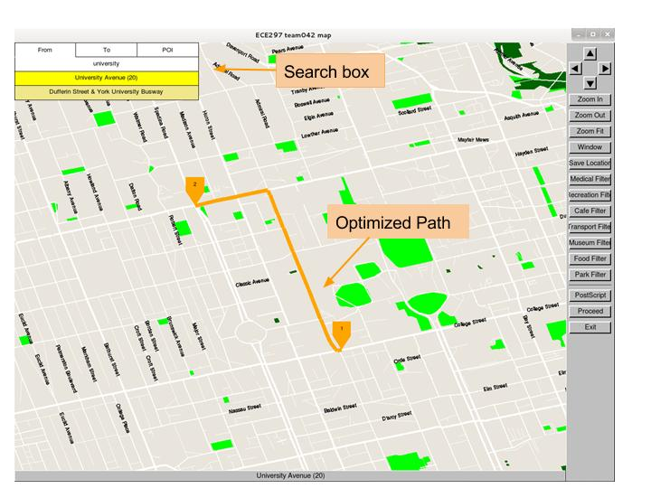

Figure 10: The implemented textbox and draw path function

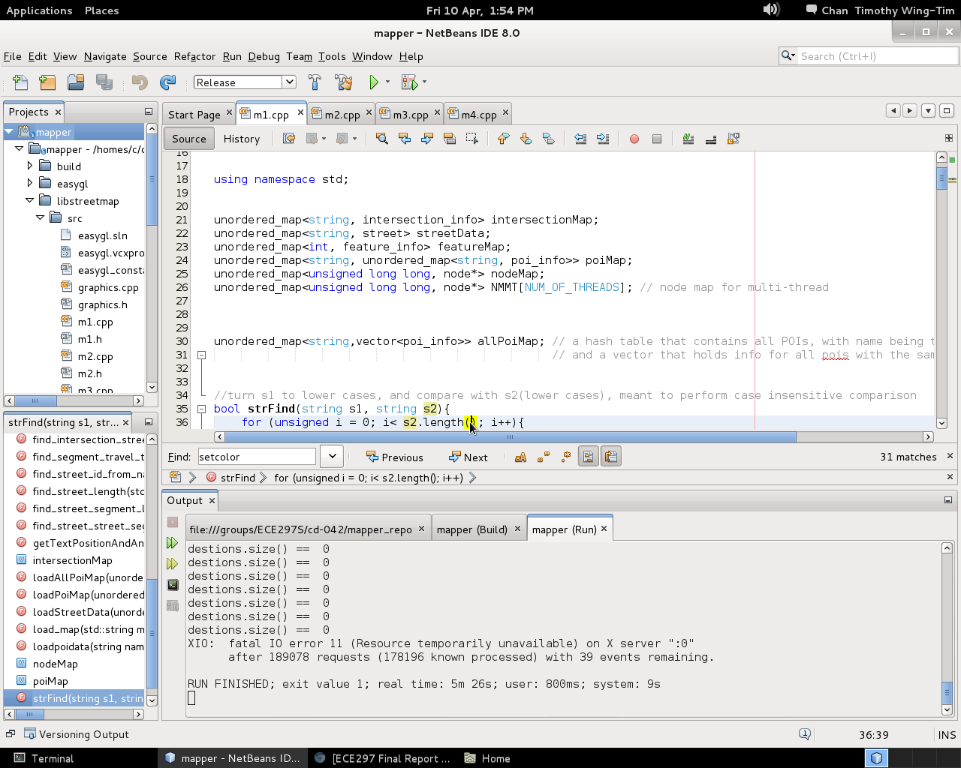

Figure 11: Data structures in m1 at the end of the project

5. Future Development

The idea of creating a travel map was developed initially because there is a market for a map system that better serves the needs of travelers [3]. The general direction of the development will remain the same in the future; the development of the map will keep tailored for travelers.

There are many GISs that provide similar functions to the travel map. In order to stand out from other competitors, travel map will target the travelers and develop into a platform that gathers people who like traveling. In the near future, travel map will be improved to solve the problems mentioned in the Lessons Learned section. Other than that, the user interface will be modified to integrate more functions, including a small map that tracks the location of the displaying map in a larger scale (Figure. 12), and a better visualization such as 3D building models standing out from the map. Travel map is still in its early development, and the major functions of the map are currently limited to navigating between different positions. In order to attract more users, travel map will be expanded into a multiplatform application that provides services including discussion boards, ratings, recommendation for trip route and attractions. Users will be able to interact with other travelers around the world, sharing opinions and recommending attractions to other travelers. These functions will be integrated with the map system for the ease of use. Travelers will be able to click on the map, and the system will list out recommendations of hotels, attractions and travel routes on the map.

Currently, travel map provides limited information on POI, only basic information such as name of POIs and the locations are provided. In the future, travel map will include a larger database that contains more useful information for travelers, including opening hours of stores and attractions, public transportation methods and public washrooms (Figure 12). The information included in the database are essential to people in a foreign city. Besides, travel map is tailored for downtown Toronto area only, and it couldn’t visualize the data from a different city properly. For example, the width of the road in New York City is poorly visualized, and failed to reflect the reality accordingly. The map system will be improved and developed to better adapt to different databases from various cities, potentially by adjusting the visualization when a new set of data is parsed into the function.

In the distant future, travel map will be able to access through applications on mobile devices. The application will be free for users to navigate when they are online, but there will also be a premium mode that enables users to access the database offline. Maps of various cities will be able for downloading for offline use when a person is visiting a foreign city, and the users will be charged for this service for 1 dollar per download. Also, the map system will cooperate with other companies like Tripadvisor to gain popularity. The map will be providing hotels, flights and trip planning functions via the support of other websites. At this final stage of development, travel map will become a platform that provides all the functions needed for travelers to plan a trip.



Figure 12: An illustration of travel map in the future

6. Conclusion

Travel map is a GIS that provides positive user experience for travelers around the world. Travel map is in the progress of being developed to a successful and popular GIS within the travelers community. Data structures and algorithms were implemented to optimize the speed of the map, which ultimately leads to a fluent user experience. Special features and functionalities including navigation, filter and save locations were implemented to match the specific needs of travelers. Besides, the design of the user interface is intuitive and simple, which also enhances the user experience. Travel map is successful in providing map service for travelers, and in the near future, the current system will be perfected with an expanded database, which provides diverse and essential information for the map users. Mobile apps will then be developed to provide an alternative platform for users. In the distant future, extra features including a rating system and a hotel/transportation booking system will be integrated with the map. Travel map is in its early stage of development, but in the future, the map will be developed into a GIS that provides numbers of functions that tailored to the needs of travelers.

7. List of References

[1] T. C. Press, "International visitors lead Toronto to new tourism records in 2013," 25 February 2014. [Online]. Available: http://globalnews.ca/news/1170935/international-visitors-lead-toronto-to-new-tourism-records-in-2013/. [Accessed 6 April 2015].

[2]"Global travel industry set for decade of sustained growth according to new report from Amadeus," Amadeus, 4 February 2014. [Online]. Available:<http://www.amadeus.com/web/amadeus/en_US-US/Amadeus-Home/News-and-events/News/04214_Global-travel-industry-set-for-decade-of-sustained-growth/1259071352352-Page-AMAD_DetailPpal?assetid=1319592754833&assettype=PressRelease_C>. [Accessed 6 2015]..

[3]W. T. Confederation, "Mobile is Beginning to Define the Multitrillion Dollar Global Travel Industry," 5 February 2014. [Online]. Available: http://www.wysetc.org/2014/02/05/mobile-is-beginning-to-define-the-multitrillion-dollar-global-travel-industry/. [Accessed 8 April 2015].

8. Attribution Table

|  |  |
| --- | --- |
| Team Member | Contributions |
| Timothy Chan | Written: Executive Summary, 1.Introduction, 4.Lessons Learned, 5.Future Development, 6.Conclusion  Creating figures in section 4. Lessons Learned and 5. Future Development  Research and Reference List  Revision: Whole Document  Editing: Whole Document |
| Zihang Fu | Written: Executive Summary, 2.Technical Overview  Creating illustrious figures in 2.Technical Overview  Timing Analysis  Revision: Whole Document  Editing: Whole Document |
| Li Ting Wong | Written: Executive Summary, 3.Product Overview  Creating illustrious figures in 3.Technical Overview  Timing Analysis  Revision: Whole Document  Editing: Whole Document |